**Supplementary material**

**Figure 1 Suppl.** Scatterplot with the latitude in the y axis and in the x axis the growing degree days, which is a measure of the cumulative annual degrees (measured as ∑(daily mean temperature – 5.5) whenever daily mean temperature > 5.5 °C) Met Office data, annual averages for 1970-2011 (Perry and Hollis, 2005). The grey dots correspond to the occurrence of common ash in Great Britain, for each 10x10km squares, data provided by the Botanical Society of the British Isles. The blue dots correspond to the provenances of study. The two orange dots correspond to the trial sites. The dotted lines correspond to the median values for latitude and for growing degree days.

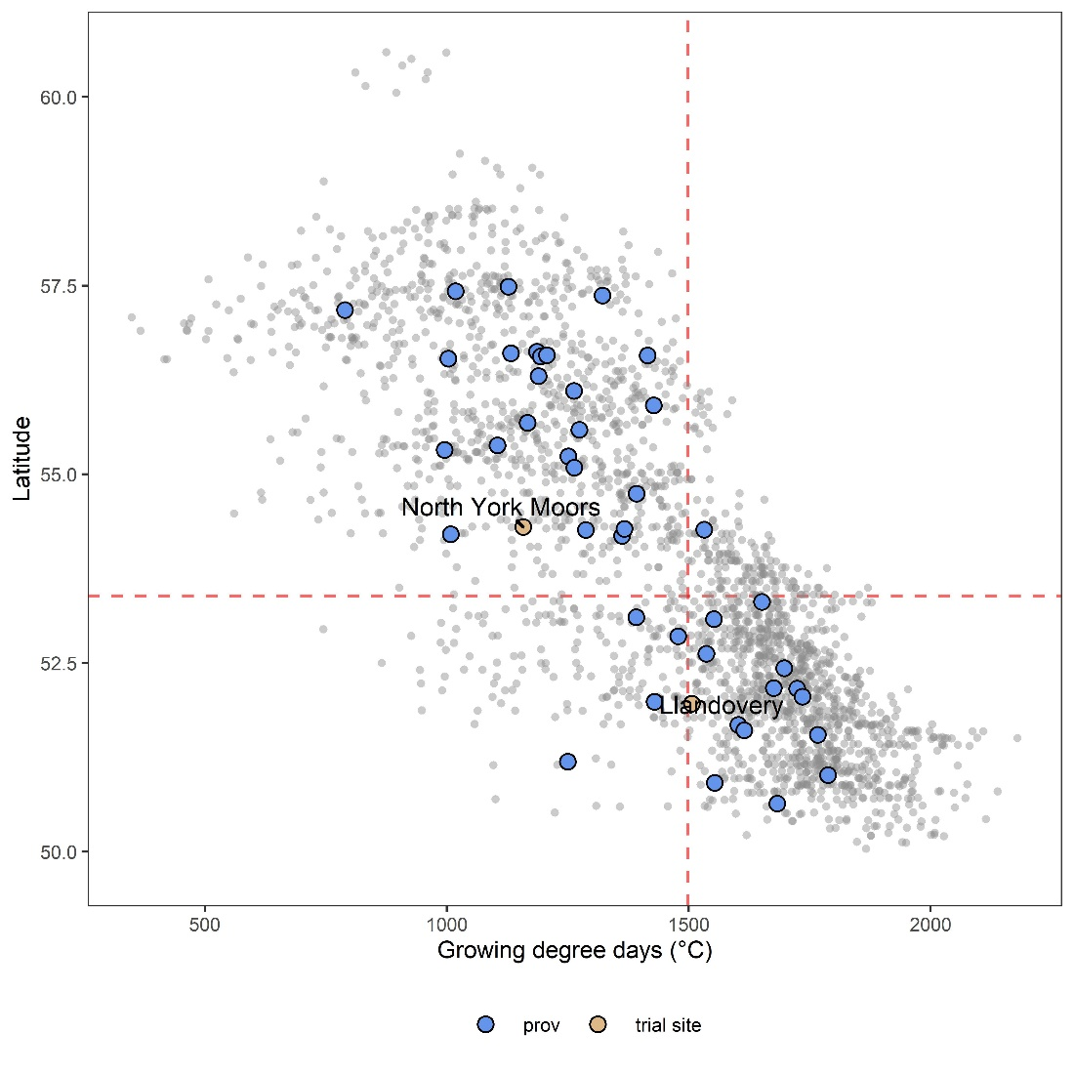

**Table 1 Suppl.** Coordinates and associated environmental information for provenance sites of origin. The “x” indicates the trial site (Llan = Llandovery; NYM = North York Moors) in which each provenance was planted. Alt = Altitude, AP = Annual precipitation, GSL = growing season length (days where temperature mean is over 5 °C for over 5 consecutive days).

|  |  |  |  |  |  |  |  |  |
| --- | --- | --- | --- | --- | --- | --- | --- | --- |
| **Provenance** | **Country** | **Lat** | **Long** | **Alt (m)** | **AP**  **(mm)** | **GSL**  **(days)** | **Site** | |
| **Llan** | **NYM** |
| Craigellachie | Scotland | 57.484 | -3.17 | 102 | 835.24 | 256.7 | x | x |
| Rassal Wood, Kishorn | Scotland | 57.426 | -5.591 | 78 | 2623.5 | 268.5 | x | x |
| Erchite Wood, Dores | Scotland | 57.368 | -4.345 | 56 | 852.79 | 285.4 | x | x |
| Duisdale, Skye | Scotland | 57.176 | -5.751 | 18 | 2041.4 | 237.2 | x | x |
| Den of Alyth | Scotland | 56.623 | -3.258 | 152 | 787.69 | 260.2 | x |  |
| Glen Lyon | Scotland | 56.602 | -4.248 | 183 | 1778.6 | 249.6 | x | x |
| Fearnan Forest, Kenmore | Scotland | 56.579 | -4.037 | 142 | 1358.4 | 256.9 | x | x |
| Glasdrum Wood, Loch Creran | Scotland | 56.574 | -5.232 | 33 | 2505.3 | 306 | x | x |
| Ardtornish,Morvern | Scotland | 56.56 | -5.741 | 20 | 2145 | 290.7 | x | x |
| Kilninian, Mull | Scotland | 56.53 | -6.208 | 71 | 1741.1 | 273.7 | x | x |
| Pitcairns Glen, Dunning | Scotland | 56.3 | -3.573 | 119 | 1318.2 | 264.9 | x | x |
| Add Valley, Kilmichael Glassary | Scotland | 56.106 | -5.42 | 30 | 1771.1 | 295.5 | x | x |
| Shielhill Glen | Scotland | 55.911 | -4.825 | 107 | 1767.7 | 309.6 | x | x |
| Clyde Valley | Scotland | 55.68 | -3.913 | 159 | 1056.2 | 263.1 | x | x |
| Tweed Valley North Glen | Scotland | 55.588 | -2.662 | 68 | 712.21 | 270.9 | x | x |
| Crawick Water | Scotland | 55.381 | -3.929 | 162 | 1270.9 | 256.1 | x | x |
| Nith Valley | Scotland | 55.32 | -3.829 | 141 | 1455.1 | 232.6 | x | x |
| Penpont | Scotland | 55.235 | -3.853 | 90 | 1294.3 | 279.2 | x | x |
| Warks Burn | England | 55.088 | -2.222 | 90 | 825.79 | 272.7 | x | x |
| Castle Eden Dene, Peterlee | England | 54.743 | -1.352 | 102 | 708.49 | 297.3 | x | x |
| Forge Valley | England | 54.274 | -0.49 | 52 | 772.92 | 283.9 | x | x |
| Witherslack | England | 54.264 | -2.87 | 79 | 1473.5 | 306.3 | x | x |
| Ashberry Woods | England | 54.262 | -1.133 | 142 | 862.85 | 266.4 | x | x |
| Upper Wharfedale | England | 54.203 | -2.104 | 202 | 1619.4 | 233 | x | x |
| Park Wood &Hutton Roof | England | 54.182 | -2.689 | 170 | 1208 | 287.3 | x | x |
| Treswell Woods | England | 53.308 | -0.861 | 54 | 616.42 | 295.7 | x |  |
| Via Gellia Woods | England | 53.104 | -1.619 | 239 | 980.75 | 285.4 | x | x |
| Betws-y-Coed | Wales | 53.079 | -3.799 | 57 | 1899.5 | 312.5 | x | x |
| Forest Bank, Marchington | England | 52.852 | -1.82 | 142 | 721.46 | 286.2 | x | x |
| Tick Wood, Ironbridge | England | 52.621 | -2.523 | 99 | 714.33 | 299.7 | x | x |
| Aberystwyth Area | Wales | 52.43 | -4.059 | 90 | 1051.2 | 329.1 | x | x |
| Out Wood | England | 52.166 | 0.415 | 96 | 623.85 | 303.9 | x | x |
| Hayley Wood | England | 52.158 | -0.11 | 79 | 562.16 | 305.2 | x | x |
| Groton Wood | England | 52.05 | 0.883 | 66 | 565.55 | 303.5 | x | x |
| Talgarth | Wales | 51.986 | -3.213 | 198 | 943.39 | 296.1 | x | x |
| Wyndcliff, Wye Valley | England | 51.678 | -2.679 | 208 | 1052.4 | 310.6 | x | x |
| Midger Wood | England | 51.606 | -2.285 | 160 | 861.5 | 301.2 | x | x |
| Cardiff Area | Wales | 51.546 | -3.234 | 158 | 1329.3 | 315.9 | x | x |
| Horner Wood, Porlock | England | 51.189 | -3.583 | 102 | 1541.2 | 293 | x | x |
| Pheasant Copse, Petworth | England | 51.011 | -0.628 | 60 | 859.63 | 318.7 | x | x |
| Bignor Hill | England | 50.908 | -0.616 | 194 | 936.24 | 300.4 | x | x |
| Greta Wood, Purbeck Ridge | England | 50.637 | -2.136 | 126 | 867.59 | 321.3 | x | x |

**Table 2 Suppl**. Stages of leaf phenology and the corresponding scores.

|  |  |  |
| --- | --- | --- |
| **Trait** | **Score** | **Description of the stage** |
| Flushing, spring phenology | 1 | Bud closed, black, fully dormant winter state. |
|  | 2 | Bud swollen but still closed, green-black in colour. |
|  | 3 | Bud scales partially separated, some leaves visible. |
|  | 4 | Bud scales completely separated, leaves visible but still furled and extending <1cm beyond scales. |
|  | 5 | Leaves elongated >1cm from scales and spreading but leaflets still furled. |
|  | 6 | All leaflets separated and shoot expanding. |
| Senescence, autumn phenology | 1 | No leaf loss |
|  | 2 | 1-25% leaf loss |
|  | 3 | 26-50% leaf loss |
|  | 4 | 51-75% leaf loss |
|  | 5 | 76-99% leaf loss |
|  | 6 | 100% leaf loss |

**Table 3 Suppl**. Simple regressions between each trait an climatic variables of the provenances. The significance (p), R-squared (R2) and slope of the regressions. Variables extrapolated climatic data provided by Met Office, 5x5 km polygons, annual averages for 1970-2011 (Perry and Hollis, 2005): GSL= growing season length (days where temperature mean is over 5 °C for over 5 consecutive days); GFD = ground frost days (Count of days when the minimum temperature is below 0 °C); AP = annual precipitation (in mm); MFT is mean February temperature; and MJT is the mean July temperature.

|  |  |  |  |  |  |  |
| --- | --- | --- | --- | --- | --- | --- |
| Trait | Trial site | Climatic Variable | | | | |
| GSL | GFD | AP | MFT | MJT |
| Height | LLAN | R2: 0.34, p<0.001  slope: 0.0084 | R2: 0.25, p<0.001  slope: -0.9262 | R2: 0.28, p<0.001  slope: -0.0309 | R2: 0.27, p<0.001  slope: 21.062 | R2: 0.46, p<0.001  slope: 20.867 |
| NYM | R2: 0.33, p<0.001  slope: 0.0030 | R2: 0.29, p<0.05  slope: -0.3708 | ns | R2: 0.28, p<0.05  slope: 6.680 | R2: 0.33, p<0.001  slope: 5.940 |
| DBH | LLAN | R2: 0.25, p<0.001  slope: 0.0131 | R2: 0.20, p<0.01  slope: -0.0156 | R2: 0.20, p<0.01  slope: -0.0004 | R2: 0.20, p<0.01  slope: 0.3166 | R2: 0.34, p<0.001  slope: 0.3430 |
| NYM | R2: 0.34, p<0.001  slope: 0.0232 | R2: 0.33, p<0.05  slope: -0.0324 | ns | R2: 0.32, p<0.05  slope: 0.5600 | R2: 0.35, p<0.01  slope: 0.4839 |
| Forks | LLAN | ns | ns | ns | ns | ns |
| NYM | R2: 0.19, p<0.001  slope: 0.0077 | R2: 0.17, p<0.01  slope: -0.0031 | ns | R2: 0.16, p<0.05  slope: 0.0581 | R2: 0.16, p<0.01  slope: 0.0349 |
| Flush | LLAN | R2:0.34, p<0.001  slope: -0.0843 | R2: 0.24, p<0.001  slope: 0.1168 | R2: 0.10, p<0.001  slope: 2.296e-03 | R2: 0.23, p<0.001  slope: -2.3387 | R2: 0.40, p<0.001  slope: -1.7382 |
| NYM | R2: 0.31, p<0.001  slope: -0.0627 | R2: 0.21, p<0.001  slope: 0.0867 | R2: 0.12, p<0.001  slope: 1.893e-03 | R2: 0.22, p<0.001  slope: -1.7283 | R2: 0.38, p<0.001  slope: -1.3563 |
| Sen | LLAN | R2: 0.29, p<0.001  slope: 0.0984 | R2: 0.23, p<0.001  slope: -0.1280 | ns | R2: 0.23, p<0.001  slope: 2.5567 | R2: 0.31, p<0.001  slope: 1.9637 |
| NYM | R2: 0.44, p<0.001  slope: 0.0425 | ns | ns | ns | R2: 0.43, p<0.05  slope: 0.7314 |

**Table 4 Suppl**. Correlation coefficient between the provenances’ latitude and the other climatic variables. Variables extrapolated climatic data provided by Met Office, 5x5 km polygons, annual averages for 1970-2011 (Perry and Hollis, 2005): GDD= growing degree days (∑(daily mean temperature – 5.5) whenever daily mean temperature > 5.5 °C); GSL= growing season length (days where temperature mean is over 5 °C for over 5 consecutive days); GFD = ground frost days (Count of days when the minimum temperature is below 0 °C); AP = annual precipitation (in mm); MFT is mean February temperature; and MJT is the mean July temperature.

|  |  |  |
| --- | --- | --- |
| **Variable** | **Correlation** | **Coefficient R and significance** |
| Growing degree days | GDD~Lat | R: -0.77, p < 0.001 |
| Growing season length | GSL~Lat | R: -0.65, p < 0.001 |
| Ground frost days | GFD~Lat | R: 0.57, p < 0.001 |
| Annual precipitation | AP~Lat | R: 0.50, p < 0.001 |
| Mean July Temperature | MJT~Lat | R: -0,79, p < 0.001 |
| Mean February Temperature | MFT~Lat | R: 0.46, p < 0.001 |